Customer Journey Map - Example

Customer journey

Customer journey maps are becoming a key tool for managing user experience plans, creating a holistic view of the customer experience by visualizing data points from different groups and stakeholders into an integrated map structure. It combines two powerful tools: storytelling and visualization to help your business understand and meet customer needs.

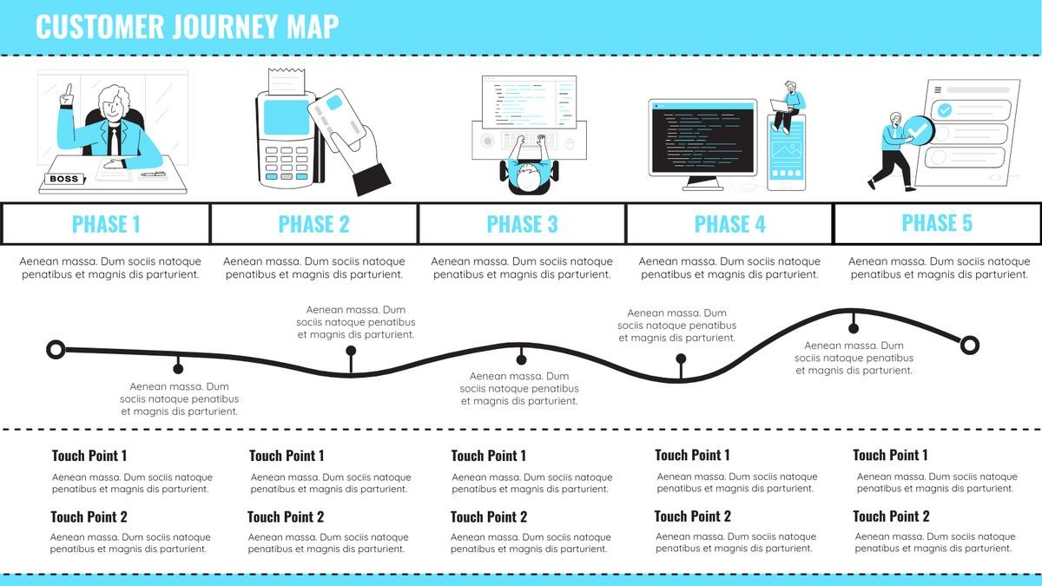

Customer journey maps simulate customer thoughts and feelings through touchpoints (points of interaction that may change how a customer feels about a product, brand, business, or service), thereby facilitating research on customer experience and enabling companies to make value-driven decisions based on customer experience models. The customer journey map helps

maintain consistency and visibility into the goals. It also helps existing products to re-validate their one-sided understanding of the our customers, allowing us to see and feel the elephant as a whole.

Customer journey maps use stories and visuals to illustrate the customer's relationship with the business over time. The story is told from the customer's point of view and provides insight into the customer's overall experience. It helps your team better understand and address customers' needs and pain points as they experience your product or service. In other words, planning a customer journey provides your business with an opportunity to understand how your brand attracts potential customers first and then through the touch points of the entire sales process

Step 1. Define your persona

Step 2. Define your customer phases

Step 3. Describe the Touchpoints Your Customer Uses to Interact with Your Organization Step 4. Conduct research

Step 5. Determine points of friction Step 6. Resolve

Step 7. Review and re-map journey on regular basis

